Use-Case Realization Report (Design)
View Site

Issue <1.0>
Revision History
Date | Issue | Description | Author
29/11/09 | 1.0 | Initial Version | Rajendran Kumaraguru

Table of Contents
1. Brief Description 4
2. Flow of Events 4
2.1 Standard Flow 4
2.2 Exception Flow 4
3. Interaction Diagrams 5
3.1 Sequenec Diagram for View Site 5
4. Participating Objects 5
5. Class Diagrams 6
5.1 Class Diagram View Site 6
6. Derived Requirements 6

Use-Case Realization Report (Design)
View Site

Brief Description
Portal admin will be able to view the site details which is already created.

Flow of Events

Standard Flow
- Portal Admin login in to the system.
- Click the btnClickViewSite.
- Loading the site details.
- Get all site details
- Validate fields will be validating the data while view the lesson.
- Portal admin will be able to view the site.

Exception Flow
  - When there is no particular lesson is not available then there should be an exception will throw lesson doesn’t exist.
  - If there is any error while performing the validate fields then exception will be thrown to portal admin.

Interaction Diagrams

Sequenec Diagram for View Site
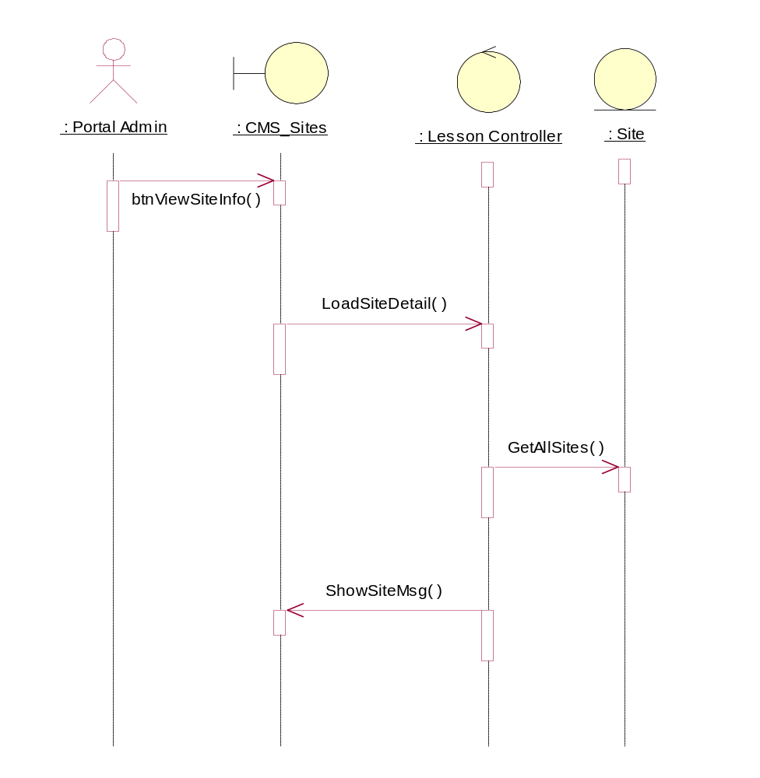

Participating Objects
: CMS_Sites

: Lesson Controller

: Portal Admin

: Site

Class Diagrams

Class Diagram View Site
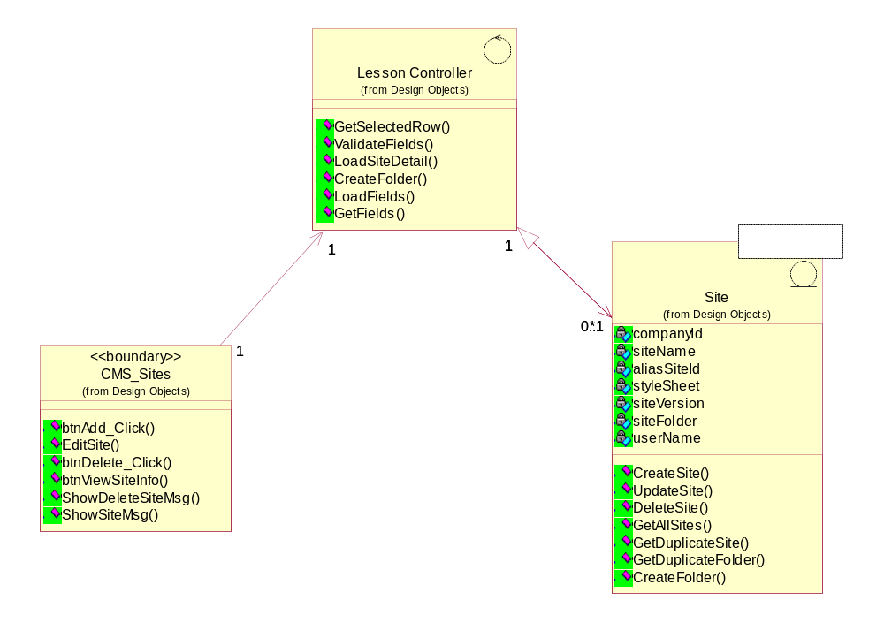

Derived Requirements
[enter the derived requirements here]

